Generating Tv-Script using

Recurrent Neural Network

INSE 6421

Project

Concordia University

Submitted By:

Meghaksh Brahmbhatt | 40166917

Binit Kumar | 40172005

April, 14th 2022

Table of Contents

What is TV Script Generation Project? 3

Expected Input Script and output Script 3

Why using Recurrent Neural Network? 3

Problem with RNN Architecture 5

Vanishing or Exploding Gradients 6

RNN Cell 6

LSTM Cell 7

Forget Gate 7

Update Gate 8

Cell state to hidden output 8

Putting it all together 9

How to fix gradient problem? 9

Framework/Library Used 10

Preprocessing of Input data 10

Creating batches of data 11

How dataloader looks like 12

Neural Network Architecture 13

Constructor 13

Forward Propagation 13

Initializing the hidden state of LSTM 14

Backpropagation 14

Training loop 16

Hyperparameters 17

Training Result 18

Script Generation 19

References 19

# What is TV Script Generation Project?

A project done by us to generate a fake Tv-script using a RNN model. We are using a Tv script from a popular Tv show named Seinfeld. The neural network takes the following mentioned tv-script, learns the text sequences from it to generate a new fake tv-script.

* Our code repository location: <https://github.com/binit92/INSE-6421>
* Seinfeld dataset from season 9. Dataset source: [https://www.kaggle.com/thec03u5/seinfeld-chronicles#scripts.csv](https://www.kaggle.com/thec03u5/seinfeld-chronicles)
* Seinfeld: <https://en.wikipedia.org/wiki/Seinfeld>

## Expected Input Script and output Script

|  |  |
| --- | --- |
| Input Sample | Output Sample |
| george: so, i was in the contrary.  george: so, i guess i was a woman, and the defendants was a good boy.  elaine: i don't know where it is.  jerry: so i was thinking about this one?  hoyt: i thought i was a little adjustment.  jerry: what is that?  hoyt: yes, yes. yes. i got a pee on this. you were in the middle of a plane, and i have a little adjustment.  george: what happened to him? | george: so you want to see how you could do that?  hoyt: i don't want to see you in a hotel.  elaine: you want to get the car on the street and a wheelchair?  hoyt: what do you think?  george: yeah, i guess i was wondering about it.  jerry: what are you doing with this girl?  elaine: no, i got to tell him.  george: i can't believe this is the most exciting thing. |

# Why using Recurrent Neural Network?

Our script generations take a word and determine the next word in a sentence. This requires keeping a sequence or order of words in the neural network. However, In Feed-Forward Network, there is no sense of order in the input. So, the question is how to build the concept of memory in the neural network so that it can learning for the sequence.

Recurrence relations need to apply at each time step t, such that model learns the concepts of memory by updating the hidden state.

|  |  |
| --- | --- |
|  |  |
| Visualizing Character-wise RNN | |
| Our goal here is to predict the next character in word “steep”   * When we pass “s”, desired output is “t”. * When we pass “t”, desired output is “e”. * When we pass “e”, desired output could be “e” or “p”. The network doesn’t have enough information to determine which character to predict!   To solve this problem, we need to include information about the sequence of characters. |  |
| We can solve this problem by routing the hidden layer output from the previous step back into the hidden layer.   * The box in the diagram means the value from the previous sequence, or time step. * Now the network sees an “e”, it knows it saw an “s” and a “t” before, so the next character should be another “e”   This architecture is known as Recurrent Neural Network or RNN   * Now the total input in the hidden layer is the sum of the layered combinations from the input layer and previous hidden layer |  |
| We can view our recurrent network as one big graph by unrolling it.   * Now, we have a feed-forward network for each character but connected through the hidden layers. * Each hidden nodes receives inputs from input node and hidden node from the previous step |  |
| Let’s visualize by adding some numbers here   * Here, we’re **one hot encoding** the input characters. * 1000 = “s”, 0100 = “t”, “0010” = “e”, 0010 = “e” * There are three units in the hidden layer and the output layer is showing the logits * We pass the logits into Softmax function to get prediction and to train with a cross entropy loss.   This is basic architecture for Character-Wise RNN. |  |
|  |  |
|  |  |

# Problem with RNN Architecture

We can include information from a sequence of data using a recurrent connection on the hidden layer. This connections goes through these weights, Whh

After enrolling the network, we say the hidden layer at step t is a function of the previous hidden state multiplied by those weights .

The output of that layer is again multiplied by Whh. For every step we have in the the network, we are multiplying by the weights again and again.

And when we do backpropagation, that’s even more multiplication. These leads to problem where gradients going through network either get really small and vanish or get really large and explode.

# Vanishing or Exploding Gradients

If we multiply by some number a bunch of times, we will get two results except a couple of special cases.

If that number is less than 1, we will end up at 0

If it greater than 1, we will head towards infinity.

This happens to gradient in normal RNN, where they either vanish or explode.

Resulting in making it difficult for RNNs to learn long range interactions.

# RNN Cell

We can think of RNNs as a bunch of cells with inputs and outputs.

Inside the cell, we have network layers, such as the sigmoid layer labelled with a sigma here.

To solve the problem of the vanishing gradients, we can use more complicated cells called long short-term memory or LSTM

# LSTM Cell

Let’s break down LSTM to understand:

The key addition here is the cell state labelled C

In this cell, there are four network layers shown as yellow boxes. Each of them with their own weights. The layers labelled with sigma are sigmoid and tanh is the hyperbolic tangent function. Tanh is similar to a sigmoid in that it squashes input, but the output is between -1 to 1 instead of 0 and 1

The red circles are point-wise or element-wise operations i.e. they operate on matrices element by element

The main improvement here is through the cell state. The cell state goes through LSTM cell with little interaction allowing information to flow easily through the cells. The cell state is modified only through element-wise operation which functions as gates.

And the hidden state is now calculated through cell state, then passed on

## Forget Gate

The first gate is the forget gate. The values coming out of sigmoid layer are between 0 and 1. Then they are multiplied element-wise with the cell state.

So the values from this layer close to 0 will shut off certain elements in the cell state. Effectively, forgetting that information going forward. Conversely, values close to 1 will allow information to pass through unchanged.

This is helpful, because the network can learn to forget information that causes incorrect predictions. On the other hand, long range information that are helpful is allowed to flow through freely

## Update Gate

The next gate updates the cell state from the input and previous hidden state.

The tanh layer output is added to the cell state and again gated by a sigmoid layer.

In this way, the cell state can be updated in the step and passed along to the next cell

## Cell state to hidden output

Here, the cell state is used to produce the hidden state which is sent to the next hidden cell as well as to higher layers. It’s the arrow pointing up here

The cell state is passed through another tanh then gated again with another sigmoid layer. All these sigmoid gates let the network learn which information to keep and which information to get rid of.

## Putting it all together

Putting all this together, the LSTM cell consists of a cell state with a bunch of gates used to update it, and leak it out to the hidden state.

This is just the basic LSTM. There are multiple variations and lot of ongoing experimentation into improving these.

They are also stacked into deeper layer. We just send the output from one cell to the input of another

# How to fix gradient problem?

Since the cell state is allowed to flow through the hidden layers with only this linear sum operation. Gradient can easily move through the network without being diminished.

We can also get gradients added into the network through the LSTM cells but they are just added to the gradients flowing through

Math behind LSTMs https://www.youtube.com/watch?v=iX5V1WpxxkY

Understanding LSTM Networks http://colah.github.io/posts/2015-08-Understanding-LSTMs/

LSTMs are basic unit of RNNs in many applications

# Framework/Library Used

Pytorch – open source machine learning framework

numpy - library for mathematical function

Pickle - library to convert Python object into byte stream etc.

# Preprocessing of Input data

Changing the entire data set into lowercase

Splitting the sentences to get all the words

Creating lookup table to generate word embeddings i.e. transforms the word to integer ids

vocab_to_int : dictionary to go from a word to id

int_to_vocab : dictionary to go from the id to word

Tokenize Punctuation

Punctuations like periods and exclamation marks can create multiple ids for the same word. For e.g. bye, bye!

This dictionary will be used to tokenize the symbols and add the delimiter (space) around it. This separates each symbols as its own word, making it easier for the neural network to predict the next word.

# Creating batches of data

batch_data function to batch words data into chunks of size batch_size using pytorch’s DataLoader classes.

DataLoader class will help to create feature_tensors and target_tensors of correct size and content of given sequence_length

E.g. words = [1, 2, 3, 4, 5, 6, 7]

sequence_length = 4

First feature_tensor would be : [1, 2, 3, 4]

The corresponding target_tensor would be: 5

Second feature_tensor would be : [2, 3, 4, 5]

And the second target_tensor would be : 6

# How dataloader looks like

Sample batch of inputs sample_x and targets sample_y from the dataloader

We are shuffling the data in the dataloader to get random batches.

# Neural Network Architecture

RNN class and constructor

## Constructor

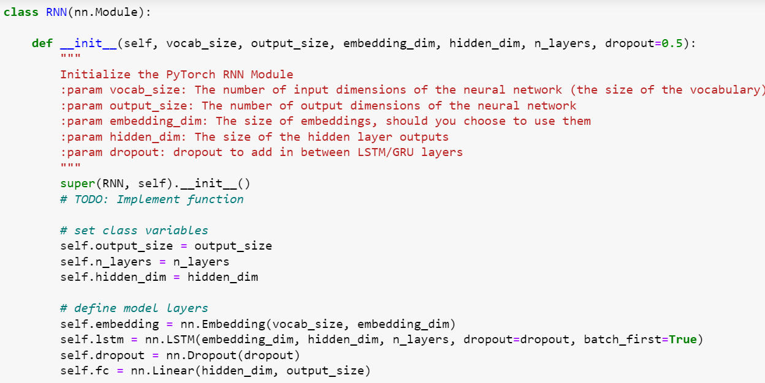

## Forward Propagation

## Initializing the hidden state of LSTM

# Backpropagation

Use the above RNN class to apply forward and back propagation

This function will be called iteratively, in the training loop

# Training loop

This function train the network over all the batches for the number of epochs given.

The model progress is printed every number of batches

# Hyperparameters

* **Sequence Length**: to set the length of the sequence
* **Batch Size** : to set the size of batches
* **Number of epochs** : to set the number of epochs to train for
* **Learning Rate**: to set the learning rate of Adam Optimizer
* **Vocab Size** : to set the number of unique tokens in vocabulary
* **Output Size** : to set the desired size of output
* **Embedding Dim** : to set the embedding dimension, smaller than vocab_size
* **Hidden Dim** : to set the hidden dimension of RNN
* **N Layer**: to set the number of layers in the RNN
* **Show N Batches**: to set the number of batches at which neural network should print progress

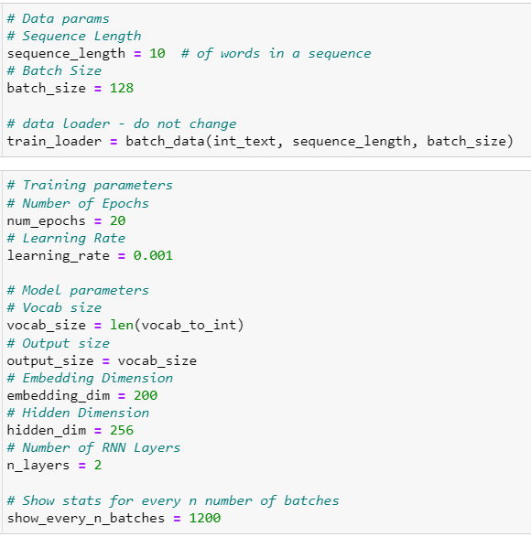

# Training Result

Using Adam Optimizer as optimizer function

Using Cross entropy loss as a loss function

Training the model

Saving the model as a physical checkpoint file after training is complete.

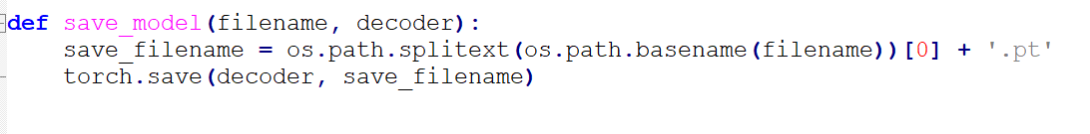

Observations

# Script Generation

# References